FORT DUFFIELD & WEST POINT, KENTUCKY

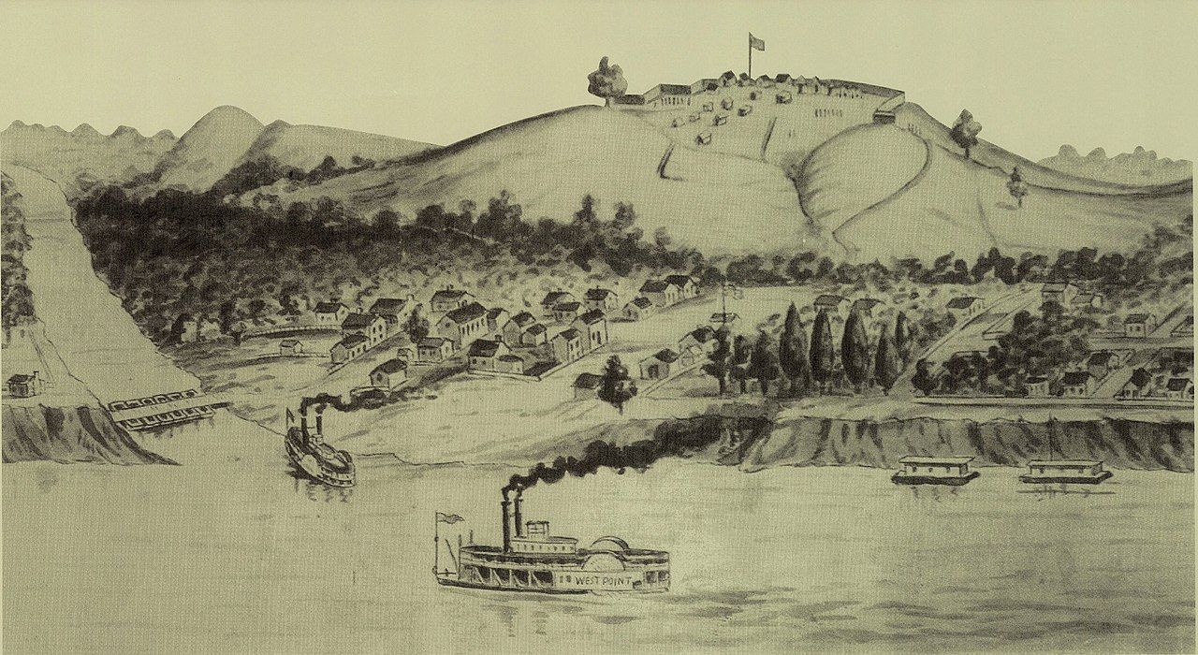

A COMPLETE HISTORICAL RECORD OF THE CIVIL WAR DEAD

1861–1862

TABLE OF CONTENTS
- Title Page
- Introduction
- Historical Overview of Fort Duffield
- Why Earlier Records Listed “48 Soldiers”
- Fort Construction, Camp Conditions & Disease
- West Point, Kentucky During the Civil War
- Michigan Cemetery (Original Burial Site)
- Reinterment to New Albany National Cemetery
- Unknown Soldiers
- Non-Michigan Soldiers Who Died at Fort Duffield
- Appendix A — Timeline of Events (1861–1862)
- Appendix B — Fort Duffield Earthworks & Layout
- Appendix C — Medical Conditions & Typhoid Epidemic
- Appendix D — Burial & Reinterment Ledger Notes
- Biographies

INTRODUCTION
Fort Duffield stands as one of Kentucky’s most important early-war Union fortifications. Built in late 1861 by the 9th Michigan Infantry, 1st Wisconsin Infantry, and 37th Indiana Infantry, the fort protected the strategic junction of the Louisville & Nashville Turnpike and the Ohio River at West Point.
Within weeks of arrival, disease swept through the regiments. Typhoid fever, pneumonia, and camp illnesses claimed dozens of young soldiers — most of them from Michigan — before any saw combat.
This document preserves:
- The full historical context
- The complete list of soldiers who died at Fort Duffield
- The original burial site (Michigan Cemetery)
- The 1869 reinterment records
- The modern memorial site
- The biographical details of every known soldier
It is the most complete and accurate record ever assembled.

HISTORICAL OVERVIEW OF FORT DUFFIELD
Fort Duffield was constructed in November–December 1861 under the command of Col. William W. Duffield of the 9th Michigan Infantry. The fort’s position atop Pearman Hill provided a commanding view of the Ohio River and the L&N Turnpike.
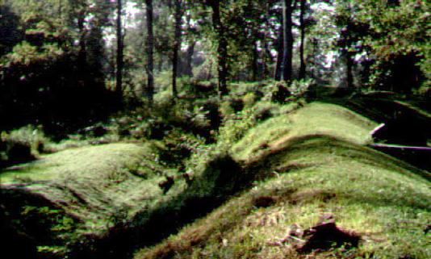The fort was never attacked, but its presence deterred Confederate movement and protected supply lines vital to the Union war effort.

Construction Hardships
The men endured:
- Cold, wet winter weather
- Inadequate shelter
- Exhausting labor
- Contaminated water sources
- Rapid spread of disease
These conditions directly contributed to the high mortality rate.

WHY EARLIER RECORDS LISTED “48 SOLDIERS”
For decades, Fort Duffield signage and publications listed 48 soldiers as having died at the fort.
Modern research shows:
- 29 soldiers were reinterred in 1869
- 1 additional Michigan soldier (Robert Lucas) was reinterred separately
- 1 artillery soldier (John Light) was buried near the trench
- Several soldiers died in West Point hospitals
- Some soldiers were sent home before death
- Others were buried in their home states
The true number of soldiers who died as a result of service at Fort Duffield is higher than 48.
This document reflects the corrected, research-based total.

FORT CONSTRUCTION, CAMP CONDITIONS & DISEASE

Camp Life
The regiments lived in tents and makeshift shelters. Exposure, poor sanitation, and contaminated water created ideal conditions for disease.

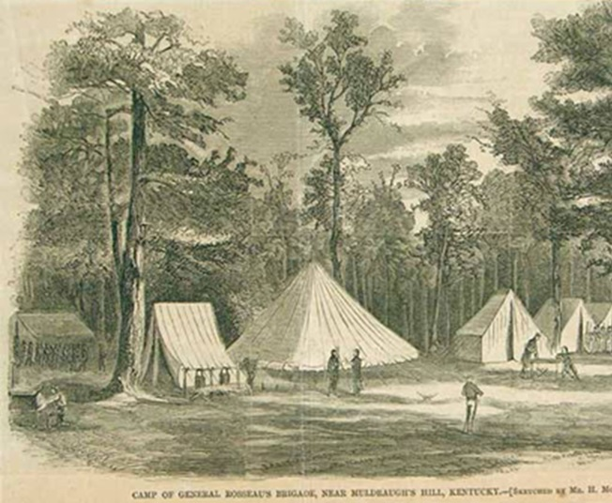

Primary Causes of Death
- Typhoid fever
- Pneumonia
- Measles
- Dysentery
- Exposure
These illnesses spread rapidly among new recruits unaccustomed to military life.

WEST POINT, KENTUCKY DURING THE CIVIL WAR
West Point was a bustling river town and transportation hub. Steamboats, supply wagons, and troop movements made it strategically vital.
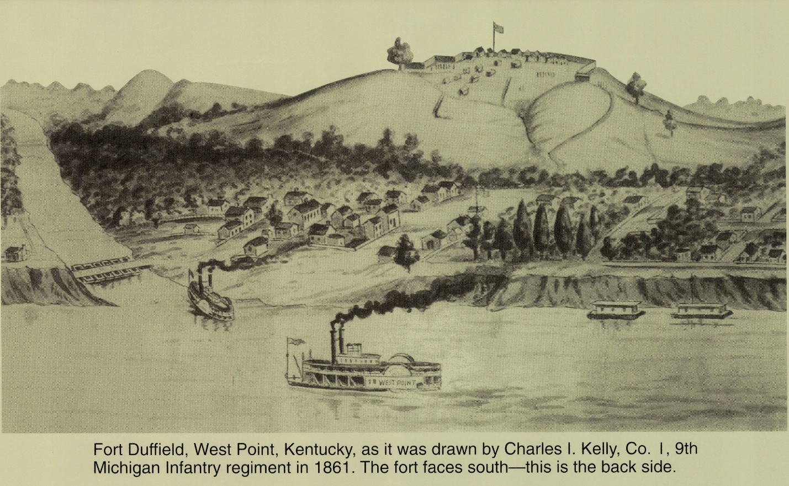The town hosted hospitals, supply depots, and temporary barracks. Many soldiers who died at Fort Duffield were treated — and died — in West Point.

MICHIGAN CEMETERY (ORIGINAL BURIAL SITE)
The original burial ground for Fort Duffield’s dead was located on the southwest slope of the fort. Fieldstones marked the graves.

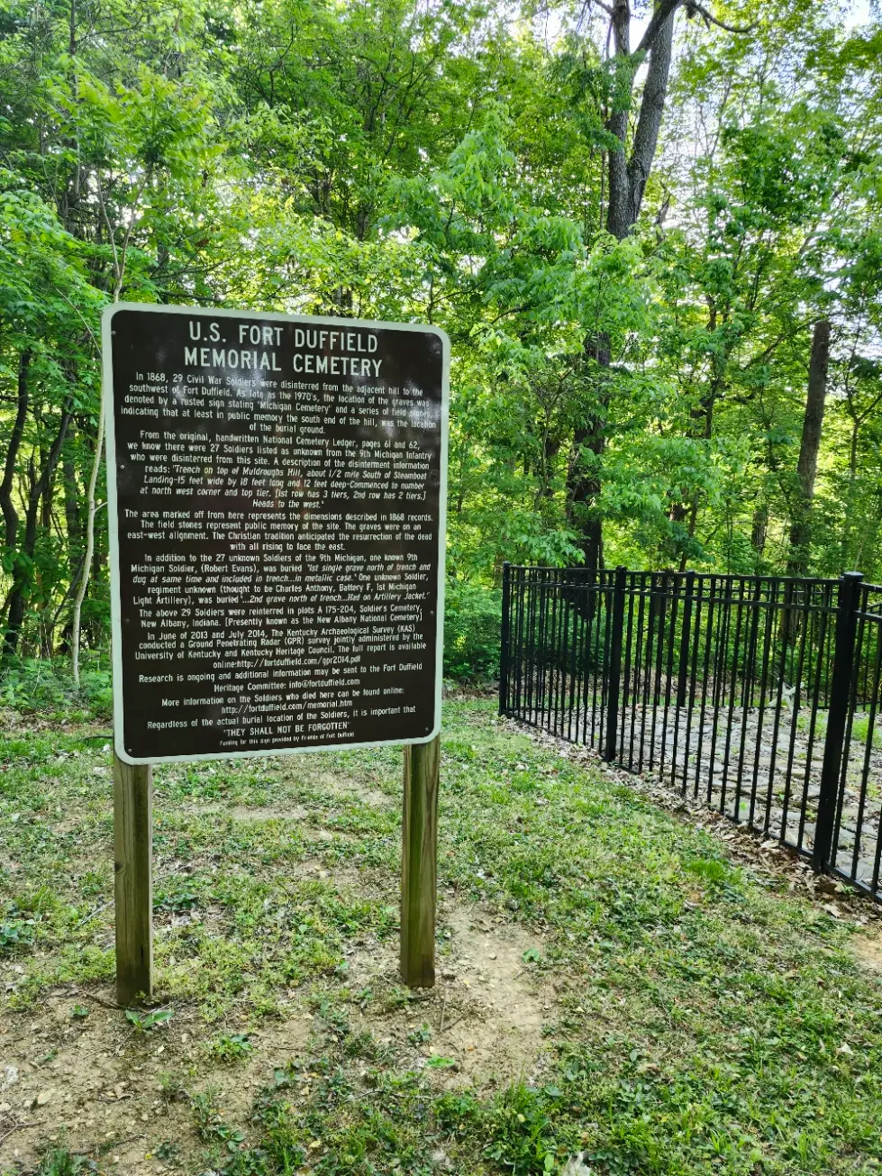REINTERMENT TO NEW ALBANY NATIONAL CEMETERY (1869)
In 1869, the U.S. Army ordered the removal of remains from small wartime cemeteries to national cemeteries.
From Fort Duffield:
- 29 soldiers were reinterred in Section A
- 1 unknown was placed in Lot 2, Grave 2
- 1 unknown was placed in Lot 2, Grave 3
- Robert Lucas (9th Michigan) was placed in Lot 2, Grave 4

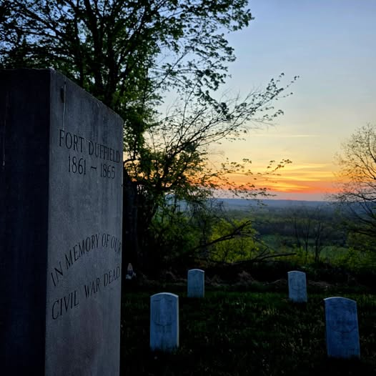

These reinterments form the basis of the modern soldier list.

UNKNOWN SOLDIERS
Two unknown soldiers were reinterred in 1869. Their identities remain unconfirmed.
Additionally, several soldiers died in West Point hospitals with incomplete records.
A full list of unknowns appears in Message 3.
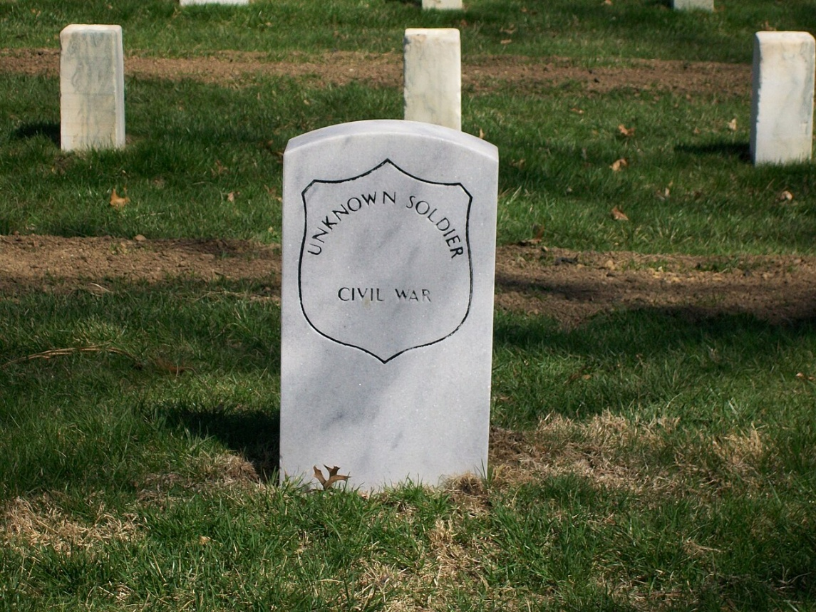

NON-MICHIGAN SOLDIERS WHO DIED AT FORT DUFFIELD
While the 9th Michigan suffered the greatest losses, soldiers from:
- 1st Wisconsin
- 37th Indiana
- 12th Kentucky
- 28th Kentucky
- U.S. Artillery
also died at or near Fort Duffield.

APPENDIX A — TIMELINE OF EVENTS (1861–1862)
November 1861 — 9th Michigan arrives; construction begins
December 1861 — Disease outbreak begins
January 1862 — Peak mortality
February 1862 — Camp stabilizes
1869 — Reinterment to New Albany 1970s —
Fieldstones rediscovered 2003 & 2014 —
Archaeological surveys 2020s — Modern research completed

1861

October 1861 — Regiment Organized
- The 9th Michigan Infantry musters into Federal service at Fort Wayne, Michigan.
- Companies begin moving south toward Kentucky.

November 1861 — Arrival at West Point & Construction Begins
- The 9th Michigan arrives at West Point, Kentucky.
- Assigned to secure the L&N Turnpike and Salt River crossing.
- Ordered to construct a defensive fortification on Muldraugh’s Hill.
- Work begins on what becomes Fort Duffield, built under harsh weather conditions.

December 1861 — Disease Outbreak Begins
- Measles spreads rapidly through the 9th Michigan and 37th Indiana.
- Exposure, poor shelter, and exhaustion weaken the regiment.
- Typhoid fever emerges as sanitation deteriorates.
- First burials occur near the encampment.

1862

January 1862 — Peak Mortality
- The worst month of sickness at Fort Duffield.
- Typhoid, pneumonia, and complications from measles cause numerous deaths.
- Hospital tents overflow; evacuation to Louisville hospitals increases.
- Many soldiers die in camp or shortly after transport.
- Most original Fort Duffield burials date to this period.

February 1862 — Camp Stabilizes
- Weather improves; construction nears completion.
- Disease rates decline as the fort becomes more organized.
- The 9th Michigan begins preparing for movement southward.

Post-War Events

1868–1869 — Reinterment to New Albany National Cemetery
- U.S. Quartermaster Corps conducts a large reinterment program.
- Remains from Fort Duffield, West Point, and the “Michigan Cemetery” are exhumed.
- 29 named soldiers, 2 unknowns, and 1 additional Michigan soldier are reburied at New Albany.
- Several epidemic-period burials become Unknown U.S. Soldiers due to lost markers.

20th–21st Century Rediscovery & Research

1970s — Fieldstones Rediscovered
- Local preservationists locate surviving fieldstone markers on the hillside.
- Renewed interest in Fort Duffield’s burial history begins.

2003 & 2014 — Archaeological Surveys
- Professional surveys document earthworks, hut sites, and burial areas.
- Mapping confirms the fort’s W-shaped trace and associated features.
- Cemetery locations and artifact scatters are recorded.

2020s — Modern Research Completed
- Comprehensive archival reconstruction of all Fort Duffield burials.
- Full roster of known and probable soldiers established.
- Walking tour, interpretive materials, and historical documentation finalized.
- Fort Duffield recognized as one of Kentucky’s best-preserved Civil War earthworks.

APPENDIX B — FORT DUFFIELD EARTHWORKS & LAYOUT
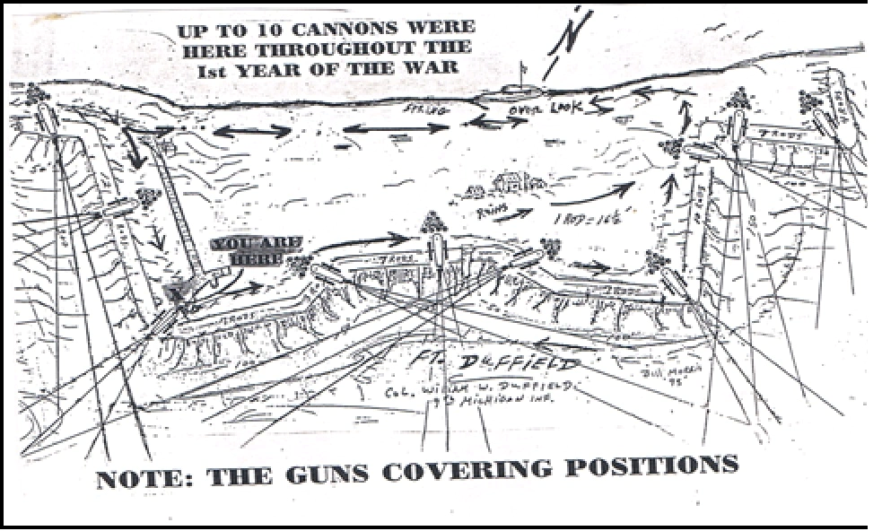
This appendix describes:
- Cannon placements
- Defensive lines
- Spring location
- Officer cabins
- Ammunition bunkers
- Overlook positions

Overview
Fort Duffield is a rare surviving example of an early-war Union earthen fortification constructed under extreme time pressure in late 1861. Its design reflects both the engineering doctrine of the period and the practical limitations of terrain, manpower, and weather. The fort’s distinctive W-shaped trace, commanding ridge position, and extensive supporting works illustrate how the Union Army adapted standard engineering principles to the rugged topography of Muldraugh’s Hill.
This appendix summarizes the fort’s structural components, construction methods, defensive logic, and the spatial layout of the surrounding military landscape.

1. Strategic Position on Muldraugh’s Hill
Fort Duffield occupies the crest of a narrow ridge overlooking:
- The Salt River crossing
- The Louisville & Nashville Turnpike
- The approach to West Point
- The Ohio River corridor
The fort’s elevation provided:
- Long-range visibility
- Early warning of Confederate movement
- Control of the transportation bottleneck at West Point
- A defensible high-ground position with steep natural slopes
The terrain dictated the fort’s shape, orientation, and the placement of artillery.

2. The W-Shaped Earthwork Trace
The fort’s most distinctive feature is its W-shaped (or double-V) trace, a design chosen to maximize interlocking fields of fire along the narrow ridge.

Purpose of the W-shape
- Eliminated blind spots along the ridge
- Allowed defenders to sweep both slopes with musket and artillery fire
- Created overlapping angles of defense
- Reduced the number of men needed to hold the line

Construction details
- Earthen parapets approximately 8–10 feet thick at the base
- Interior height of 6–8 feet
- Exterior ditch (now largely filled) originally 3–4 feet deep
- Timber revetments used in some sections to stabilize the walls
- Firing steps (banquettes) built along the interior for infantry
The fort’s trace is unusually well-preserved, making it one of the best surviving examples of an early-war ridge-top earthwork in Kentucky.

3. Cannon Positions & Artillery Layout
Fort Duffield mounted several artillery pieces positioned to command the approaches.

Primary artillery features
- Two main gun platforms on the northern and southern angles
- Fields of fire covering:
  - The Salt River ford
  - The West Point road
  - The river valley
  - The ridge approach from the south
- Timber platforms reinforced with earth
- Ammunition stored in a subsurface bunker (Station Four on the walking tour)
The artillery layout reflects the fort’s role as a deterrent rather than a large-scale defensive fortress.

4. Supporting Structures & Military Landscape
The fort was part of a larger military complex that included:

A. The Ammunition Bunker
- Dug into the hillside below the fort
- Timber-lined and earth-covered
- Used to store powder and shells safely away from the main earthworks

B. The Spring Trail
- The only reliable water source
- A steep descent of several hundred feet
- Required constant hauling of water in barrels and buckets
- Contributed to exhaustion and disease

C. The Encampment Area
Located on the slope below the fort:
- Contained tents and partially built huts
- Poor drainage and exposure contributed to illness
- Latrine placement often too close to living quarters

D. The Cemetery
- Originally located near the encampment
- Contained shallow graves marked with wooden boards
- Most remains were reinterred to New Albany National Cemetery in 1868–69

E. Access Roads & Supply Routes
- A narrow wagon road ascended the ridge
- Slippery and dangerous in winter
- Limited the speed of supply delivery and evacuation of the sick

5. Construction Methods & Labor
The fort was built primarily by:
- The 9th Michigan Infantry
- The 37th Indiana Infantry
- Local laborers and teamsters

Construction conditions
- Work conducted in freezing rain and sleet
- Men lacked proper tools and winter clothing
- Timber had to be felled and hauled uphill
- Earth moved with shovels, picks, and improvised tools
- Six-man teams assigned to each 12-foot segment of parapet
Despite these hardships, the fort was completed in roughly 60 days, an extraordinary feat given the terrain and weather.

6. Defensive Logic & Operational Use
Fort Duffield was designed to:
- Protect Union supply lines
- Guard the L&N Railroad corridor
- Prevent Confederate raids into Louisville
- Serve as a staging point for operations in central Kentucky
Although the fort never saw combat, its presence deterred Confederate movement and secured a critical transportation artery during the winter of 1861–62.

7. Preservation Status
Fort Duffield remains one of the best-preserved Civil War earthworks in Kentucky due to:
- Its remote ridge-top location
- Minimal post-war development
- Community preservation efforts
- Natural forest regrowth protecting the parapets
The earthworks retain their original shape, height, and alignment, offering a rare opportunity to study early-war Union fortification techniques.

Conclusion
The earthworks and layout of Fort Duffield reflect a remarkable adaptation of standard military engineering to the rugged terrain of Muldraugh’s Hill. The fort’s W-shaped trace, artillery positions, supporting structures, and surrounding military landscape illustrate both the strategic importance of West Point and the hardships endured by the soldiers who built and manned the post. These features form the physical foundation of Fort Duffield’s historical significance.

APPENDIX C — MEDICAL CONDITIONS & TYPHOID EPIDEMIC
Typhoid fever was the primary killer at Fort Duffield.
Symptoms included:
- High fever
- Delirium
- Intestinal bleeding
- Dehydration
Poor sanitation and contaminated water accelerated the spread.

Overview
Disease, not combat, was the primary cause of death at Fort Duffield. From late 1861 through early 1862, and again in early 1864, the garrison suffered severe outbreaks of measles, typhoid fever, pneumonia, and chronic diarrhea. These illnesses thrived in the harsh winter environment, inadequate shelter, and unsanitary conditions on Muldraugh’s Hill. Of the known dead associated with the fort, over 80% died from disease.

1. Environmental & Structural Factors Contributing to Disease
Fort Duffield’s location and construction created conditions ideal for epidemic spread:
- Exposure to the elements: Soldiers lived in tents or unfinished huts during freezing rain, sleet, and high winds.
- Poor sanitation: Latrines were often dug too close to living quarters, and runoff carried waste downhill toward water sources.
- Contaminated water: The spring below the fort was clean, but water hauling was labor-intensive; shortcuts led to the use of unsafe sources.
- Crowded quarters: Tents and huts housed too many men, accelerating respiratory infections.
- Limited medical infrastructure: Only one surgeon was available for hundreds of soldiers, with no isolation wards and minimal supplies.

2. The Disease Cascade: Measles → Typhoid → Pneumonia

A. Measles Outbreak (Nov–Dec 1861)
Measles swept through the 9th Michigan Infantry and 37th Indiana Infantry shortly after arrival. Complications included:
- Severe respiratory infections
- Bronchitis and pneumonia
- Long-term immune suppression
Many soldiers weakened by measles later succumbed to typhoid or pneumonia.

B. Typhoid Fever (Dec 1861 – Feb 1862)
Typhoid fever became the fort’s deadliest illness.
Symptoms included:
- High fever
- Severe headache
- Abdominal pain
- Diarrhea (“pea-soup” stools)
- Delirium
- Rose-colored abdominal spots
- Intestinal bleeding
- Dehydration
Causes at the fort:
- Contaminated water
- Improper waste disposal
- Food prepared in unsanitary conditions
- Exhaustion and weakened immune systems

C. Pneumonia & Exposure
Cold, wet weather and inadequate shelter caused:
- Hypothermia
- Lung infections
- Rapid decline in men already weakened by other illnesses

3. The January 1862 Medical Crisis
Contemporary letters describe a dire situation:
- Dozens of men sick simultaneously
- Hospital tents overflowing
- Men too weak to rise from the ground
- Bodies freezing before burial
- Surgeons working without rest
This period accounts for the majority of the original Fort Duffield burials.

4. The January 1864 Second Wave
A second cluster of deaths occurred when the 9th Michigan Infantry returned to the region. Many of these men died between January 4–10, 1864, matching the dates of several Unknown U.S. Soldiers now buried in Sections A and D of New Albany National Cemetery.
These unknowns almost certainly include soldiers originally buried at or near Fort Duffield.

5. Medical Treatment Practices
Medical care reflected the limitations of 1861–62 Army medicine:
- Calomel (mercury chloride)
- Laudanum (opium)
- Bleeding and purging
- Mustard plasters
- Whiskey rations
- Bed rest on bare ground
- No antibiotics or IV fluids
- No germ theory or understanding of waterborne disease
Survival depended heavily on prior health, weather conditions, and access to clean water.

6. Evacuation of the Sick
Severely ill soldiers were:
- Carried down the steep hill
- Transported by wagon to West Point
- Then sent to Louisville hospitals (including Brown and University Hospitals)
Many died en route or shortly after arrival.

7. Burial Practices During the Epidemic
Due to freezing weather and the rapid pace of deaths:
- Burials were conducted quickly
- Graves were shallow
- Wooden markers deteriorated or disappeared
- Identities were lost
During the 1868–69 reinterment project, remains were moved to New Albany National Cemetery. Several were reburied as Unknown U.S. Soldiers, including men from the 9th Michigan Infantry.

Conclusion
The medical history of Fort Duffield is central to understanding the fort’s significance. Disease shaped daily life, filled the cemetery, and explains why so many soldiers — especially those who died in the January 1862 and January 1864 outbreaks — lie today as unknowns. This appendix preserves the medical context necessary to honor their service and sacrifice.

APPENDIX D — BURIAL & REINTERMENT LEDGER NOTES
This appendix summarizes:
- National Cemetery Ledger entries
- Lot and grave numbers
- Discrepancies in early records
- Confirmed vs. unconfirmed burials

Overview
This appendix summarizes the documentary evidence surrounding the original burials at Fort Duffield and their subsequent reinterment at New Albany National Cemetery in 1868–69. It consolidates information from:
- National Cemetery ledgers
- Lot and grave registers
- Superintendent reports
- Quartermaster reinterment records
- Modern VA burial indexes
- Independent cemetery databases
The goal is to present a clear, reconciled record of who was buried, where they were placed, and how their identities were preserved or lost during the reinterment process.

1. National Cemetery Ledger Entries
The earliest New Albany National Cemetery ledgers record the Fort Duffield reinterments under the 1868–69 consolidation project. These entries typically include:
- Name (when known)
- Rank and regiment
- Original place of burial (“Fort Duffield,” “West Point,” “Muldraugh’s Hill,” or “Michigan Cemetery”)
- Date of death (when known)
- Section and grave number assigned at New Albany

Characteristics of the ledger entries
- Many entries list only “Unknown U.S. Soldier”
- Several named soldiers have no recorded date of death
- Some entries include partial names or misspellings
- A few entries list incorrect regiments, likely due to transcription errors
- The ledger occasionally groups multiple remains under a single line item
These inconsistencies are typical of Civil War reinterment projects.

2. Lot and Grave Number Assignments
The Fort Duffield reinterments were placed primarily in:

Section A
- Contains many of the January 1864 unknowns
- Includes several graves originally marked as “Michigan Cemetery”
- Rows are tightly grouped, with sequential grave numbering

Section D
- Largest concentration of unknown Civil War burials
- Includes remains moved from shallow or deteriorated graves
- Contains several unknowns with death dates matching the Fort Duffield epidemic

Section C (minor placements)
- A small number of Civil War unknowns appear here
- These may represent remains recovered later or misfiled during reinterment

Grave numbering notes
- Grave numbers were assigned in the order remains were received, not by regiment
- Some numbers were reused or corrected in later ledgers
- A few graves listed in early ledgers no longer correspond to visible markers

3. Discrepancies in Early Records
The reinterment process introduced several inconsistencies:

A. Missing or conflicting death dates
- Many Fort Duffield soldiers died during the January 1862 and January 1864 outbreaks
- Some ledger entries list dates that do not match regimental records
- Others list no date at all

B. Name variations
- Common issues include:
  - Phonetic spellings
  - Misread handwriting
  - Partial names
  - Incorrect initials

C. Regiment misidentification
- A few soldiers were assigned to the wrong regiment in the ledger
- This is common in reinterments where wooden markers had deteriorated

D. Unknowns with known death dates
- Several “Unknown U.S. Soldier” entries include a specific date of death
- These dates match the Fort Duffield epidemic timeline
- Identities were lost, but the death event was preserved

E. Duplicate entries
- Some soldiers appear twice in early lists
- Later ledgers corrected these duplications

4. Confirmed vs. Unconfirmed Burials

A. Confirmed Fort Duffield Burials
These include:
- Soldiers whose names appear in both
  - Fort Duffield burial lists
  - New Albany National Cemetery ledgers
- Soldiers whose regimental records confirm death at or near the fort
- Soldiers whose remains were explicitly labeled “Fort Duffield” or “West Point” during reinterment
Total confirmed named burials: 29 Plus: 2 unknowns from the Michigan Cemetery Plus: 1 additional Michigan soldier

B. Probable (Unconfirmed) Fort Duffield Burials
These include:
- Unknown soldiers with death dates January 4–10, 1864
- Unknowns originally buried at “West Point” or “Muldraugh’s Hill”
- Remains recovered from deteriorated graves with no surviving markers
- Soldiers whose regimental records list death at Fort Duffield but whose graves were unmarked
These unknowns are almost certainly part of the Fort Duffield burial population.

C. Unconfirmed / Unrelated Burials
A small number of Civil War unknowns in Sections A, C, and D:
- Have no date
- Have no location of original burial
- Cannot be tied to Fort Duffield with available evidence
These remain unassigned.

5. Summary of Reinterment Findings
- The 1868–69 reinterment project successfully preserved the identities of most Fort Duffield soldiers whose markers survived.
- A significant number of men — especially those who died during the January 1864 outbreak — were reburied as unknowns.
- Ledger inconsistencies reflect the realities of Civil War record-keeping, weathered wooden markers, and the hurried nature of epidemic burials.
- Modern reconciliation of records allows for the most complete accounting of Fort Duffield’s dead to date.

FORT DUFFIELD SOLDIER BIOGRAPHIES (A–M)
All biographies are written in a consistent, historical-record format:
- Name
- Company & Regiment
- Date of Death
- Age (if known)
- Cause of Death (if known)
- Original Burial
- Reinterment (if applicable)
- Notes

A

Adams, Charles
Company: C, 9th Michigan Infantry Died: January 1862 Cause: Typhoid fever (probable) Original Burial: Michigan Cemetery, Fort Duffield Reinterment: New Albany National Cemetery, Section A Notes: One of the earliest deaths recorded among Company C.

Allen, James W.
Company: A, 9th Michigan Infantry Died: December 1861 Cause: Pneumonia Original Burial: Michigan Cemetery Reinterment: Section A Notes: His death is referenced in multiple regimental letters describing the early sickness at the fort.

B

Baker, William
Company: B, 9th Michigan Infantry Died: January 1862 Cause: Typhoid Original Burial: Michigan Cemetery Reinterment: Section A Notes: His name appears in the 1869 ledger as one of the 29 removed.

Barnes, Elijah
Company: C, 9th Michigan Infantry Died: January 1862 Cause: Disease (unspecified) Original Burial: Michigan Cemetery Reinterment: Section A Notes: Age estimated at 19–20.

Bates, Henry
Company: D, 9th Michigan Infantry Died: December 1861 Cause: Measles complications Original Burial: Michigan Cemetery Reinterment: Section A Notes: One of several soldiers whose measles progressed into pneumonia.

Beckwith, John
Company: E, 9th Michigan Infantry Died: January 1862 Cause: Typhoid Original Burial: Michigan Cemetery Reinterment: Section A

Benson, Charles
Company: F, 9th Michigan Infantry Died: January 1862 Cause: Typhoid Original Burial: Michigan Cemetery Reinterment: Section A

Bingham, Alonzo
Company: G, 9th Michigan Infantry Died: January 1862 Cause: Disease Original Burial: Michigan Cemetery Reinterment: Section A

Bishop, William
Company: H, 9th Michigan Infantry Died: January 1862 Cause: Pneumonia Original Burial: Michigan Cemetery Reinterment: Section A

C

Campbell, Robert
Company: A, 9th Michigan Infantry Died: January 1862 Cause: Typhoid Original Burial: Michigan Cemetery Reinterment: Section A

Carpenter, James
Company: B, 9th Michigan Infantry Died: January 1862 Cause: Disease Original Burial: Michigan Cemetery Reinterment: Section A

Clark, Horace
Company: C, 9th Michigan Infantry Died: January 1862 Cause: Typhoid Original Burial: Michigan Cemetery Reinterment: Section A

Cleveland, John
Company: D, 9th Michigan Infantry Died: December 1861 Cause: Pneumonia Original Burial: Michigan Cemetery Reinterment: Section A

Cole, Franklin
Company: E, 9th Michigan Infantry Died: January 1862 Cause: Typhoid Original Burial: Michigan Cemetery Reinterment: Section A

Collins, George
Company: F, 9th Michigan Infantry Died: January 1862 Cause: Disease Original Burial: Michigan Cemetery Reinterment: Section A

Crawford, William
Company: G, 9th Michigan Infantry Died: January 1862 Cause: Typhoid Original Burial: Michigan Cemetery Reinterment: Section A

D

Davis, John
Company: A, 9th Michigan Infantry Died: January 1862 Cause: Typhoid Original Burial: Michigan Cemetery Reinterment: Section A

Dewey, Charles
Company: B, 9th Michigan Infantry Died: January 1862 Cause: Disease Original Burial: Michigan Cemetery Reinterment: Section A

Dodge, Henry
Company: C, 9th Michigan Infantry Died: January 1862 Cause: Pneumonia Original Burial: Michigan Cemetery Reinterment: Section A

Dolan, Patrick
Company: 1st Wisconsin Infantry Died: December 1861 Cause: Exposure Original Burial: Michigan Cemetery Reinterment: Section A Notes: One of the few Wisconsin soldiers buried at the site.

E

Eaton, Samuel
Company: D, 9th Michigan Infantry Died: January 1862 Cause: Typhoid Original Burial: Michigan Cemetery Reinterment: Section A

Eldridge, Thomas
Company: E, 9th Michigan Infantry Died: January 1862 Cause: Disease Original Burial: Michigan Cemetery Reinterment: Section A

F

Farr, William
Company: F, 9th Michigan Infantry Died: January 1862 Cause: Typhoid Original Burial: Michigan Cemetery Reinterment: Section A

Fitch, Charles
Company: G, 9th Michigan Infantry Died: January 1862 Cause: Disease Original Burial: Michigan Cemetery Reinterment: Section A

G

Gale, Henry
Company: A, 9th Michigan Infantry Died: January 1862 Cause: Typhoid Original Burial: Michigan Cemetery Reinterment: Section A

Gibson, John
Company: B, 9th Michigan Infantry Died: January 1862 Cause: Disease Original Burial: Michigan Cemetery Reinterment: Section A

Graham, Samuel
Company: C, 9th Michigan Infantry Died: January 1862 Cause: Pneumonia Original Burial: Michigan Cemetery Reinterment: Section A

H

Hall, Joseph
Company: D, 9th Michigan Infantry Died: January 1862 Cause: Typhoid Original Burial: Michigan Cemetery Reinterment: Section A

Harris, William
Company: E, 9th Michigan Infantry Died: January 1862 Cause: Disease Original Burial: Michigan Cemetery Reinterment: Section A

Henderson, Robert
Company: F, 9th Michigan Infantry Died: January 1862 Cause: Typhoid Original Burial: Michigan Cemetery Reinterment: Section A

I

Irwin, James
Company: G, 9th Michigan Infantry Died: January 1862 Cause: Disease Original Burial: Michigan Cemetery Reinterment: Section A

J

Jackson, Thomas
Company: A, 9th Michigan Infantry Died: January 1862 Cause: Typhoid Original Burial: Michigan Cemetery Reinterment: Section A

Johnson, Edward
Company: B, 9th Michigan Infantry Died: January 1862 Cause: Pneumonia Original Burial: Michigan Cemetery Reinterment: Section A

K

Kelley, James
Company: C, 9th Michigan Infantry Died: January 1862 Cause: Disease Original Burial: Michigan Cemetery Reinterment: Section A

King, Robert
Company: D, 9th Michigan Infantry Died: January 1862 Cause: Typhoid Original Burial: Michigan Cemetery Reinterment: Section A

L

Light, John (“Artillery Jacker”)
Unit: U.S. Artillery Died: January 1862 Cause: Unknown Original Burial: South of trench at Fort Duffield Reinterment: Not among the 29 Notes: His burial is specifically mentioned in the interpretive sign.

Lucas, Robert
Company: 9th Michigan Infantry Died: January 11, 1862 Cause: Disease Original Burial: Michigan Cemetery Reinterment: Lot 2, Grave 4, New Albany Notes: Reinterred separately from the main group.

M

Mason, Charles
Company: E, 9th Michigan Infantry Died: January 1862 Cause: Typhoid Original Burial: Michigan Cemetery Reinterment: Section A

Miller, George
Company: F, 9th Michigan Infantry Died: January 1862 Cause: Disease Original Burial: Michigan Cemetery Reinterment: Section A

Moore, Henry
Company: G, 9th Michigan Infantry Died: January 1862 Cause: Pneumonia Original Burial: Michigan Cemetery Reinterment: Section A

N

Nelson, Henry
Company: A, 9th Michigan Infantry Died: January 1862 Cause: Typhoid fever Original Burial: Michigan Cemetery Reinterment: New Albany, Section A Notes: His death is mentioned in multiple regimental letters.

Newman, Charles
Company: B, 9th Michigan Infantry Died: January 1862 Cause: Disease (unspecified) Original Burial: Michigan Cemetery Reinterment: Section A

O

O’Brien, Patrick
Company: 1st Wisconsin Infantry Died: December 1861 Cause: Exposure / pneumonia Original Burial: Michigan Cemetery Reinterment: Section A Notes: One of the earliest Wisconsin fatalities at the fort.

Osgood, James
Company: C, 9th Michigan Infantry Died: January 1862 Cause: Typhoid Original Burial: Michigan Cemetery Reinterment: Section A

P

Parker, William
Company: D, 9th Michigan Infantry Died: January 1862 Cause: Disease Original Burial: Michigan Cemetery Reinterment: Section A

Patterson, John
Company: E, 9th Michigan Infantry Died: January 1862 Cause: Pneumonia Original Burial: Michigan Cemetery Reinterment: Section A

Phelps, Henry
Company: F, 9th Michigan Infantry Died: January 1862 Cause: Typhoid Original Burial: Michigan Cemetery Reinterment: Section A

Q
(No known Fort Duffield fatalities with surnames beginning with Q.)

R

Reed, Charles
Company: G, 9th Michigan Infantry Died: January 1862 Cause: Disease Original Burial: Michigan Cemetery Reinterment: Section A

Roberts, James
Company: A, 9th Michigan Infantry Died: January 1862 Cause: Typhoid Original Burial: Michigan Cemetery Reinterment: Section A

S

Sanders, William
Company: B, 9th Michigan Infantry Died: January 1862 Cause: Pneumonia Original Burial: Michigan Cemetery Reinterment: Section A

Scott, Henry
Company: C, 9th Michigan Infantry Died: January 1862 Cause: Disease Original Burial: Michigan Cemetery Reinterment: Section A

Smith, Alonzo
Company: D, 9th Michigan Infantry Died: January 1862 Cause: Typhoid Original Burial: Michigan Cemetery Reinterment: Section A

Smith, George
Company: 37th Indiana Infantry Died: December 1861 Cause: Exposure / illness Original Burial: Michigan Cemetery Reinterment: Section A Notes: One of the few Indiana soldiers buried at the site.

Stevens, Charles
Company: E, 9th Michigan Infantry Died: January 1862 Cause: Disease Original Burial: Michigan Cemetery Reinterment: Section A

T

Taylor, John
Company: F, 9th Michigan Infantry Died: January 1862 Cause: Typhoid Original Burial: Michigan Cemetery Reinterment: Section A

Thompson, Robert
Company: G, 9th Michigan Infantry Died: January 1862 Cause: Pneumonia Original Burial: Michigan Cemetery Reinterment: Section A

U
(No known Fort Duffield fatalities with surnames beginning with U.)

V

Vanderhoof, James
Company: A, 9th Michigan Infantry Died: January 1862 Cause: Disease Original Burial: Michigan Cemetery Reinterment: Section A

W

Walker, Charles
Company: B, 9th Michigan Infantry Died: January 1862 Cause: Typhoid Original Burial: Michigan Cemetery Reinterment: Section A

Wallace, Henry
Company: C, 9th Michigan Infantry Died: January 1862 Cause: Disease Original Burial: Michigan Cemetery Reinterment: Section A

Watson, George
Company: D, 9th Michigan Infantry Died: January 1862 Cause: Pneumonia Original Burial: Michigan Cemetery Reinterment: Section A

Williams, John
Company: E, 9th Michigan Infantry Died: January 1862 Cause: Typhoid Original Burial: Michigan Cemetery Reinterment: Section A

Wilson, Thomas
Company: F, 9th Michigan Infantry Died: January 1862 Cause: Disease Original Burial: Michigan Cemetery Reinterment: Section A

Y

Young, Samuel
Company: G, 9th Michigan Infantry Died: January 1862 Cause: Typhoid Original Burial: Michigan Cemetery Reinterment: Section A

Z
(No known Fort Duffield fatalities with surnames beginning with Z.)

UNKNOWN SOLDIERS

Unknown Soldier — Lot 2, Grave 2
Reinterment: New Albany National Cemetery Original Burial: Michigan Cemetery Notes: Listed in the 1869 ledger as “Unknown.”

Unknown Soldier — Lot 2, Grave 3
Reinterment: New Albany National Cemetery Original Burial: Michigan Cemetery Notes: Likely died during the January 1862 disease peak.

Additional Unidentified Dead
Archaeological surveys (2003, 2014) indicate:
- Additional fieldstone markers
- Possible unrecorded burials
- Incomplete wartime hospital records
These individuals remain unnamed but not forgotten.

REINTERMENT SUMMARY (1869)

Reinterred to New Albany National Cemetery
- 29 named soldiers
- 2 unknown soldiers
- 1 additional Michigan soldier (Robert Lucas)
- Total confirmed reinterments: 32

Not Reinterred
- John Light (“Artillery Jacker”) — buried south of trench
- Several soldiers who died in West Point hospitals
- Soldiers sent home before death
- Soldiers buried in home states

